**Session 15**

1. A _function__ is a self-contained program segment that carries out a specific, well-defined task.
2. Arguments appearing in the parentheses are termed as _formal-parameters or

formal-arguments_.

1. If the return is ignored, control passes to the calling program when the closing braces of  
   the code block are encountered. This is termed as _return (0) or return__.

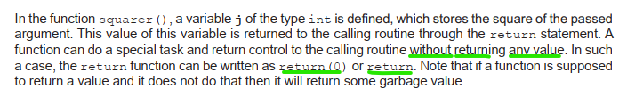

1. The function, which calls another function, is known as the _calling function__ and the function, which is being called, is known as the _called function__.
2. A _function prototype_ is a function declaration that specifies the data types of the arguments.
3. _Local variables__ can be referred to only by statements that are inside the code block, which declares them.
4. _Global variables__ are visible to the entire program, and can be used by any piece of code.
5. _Scope rules_ govern whether one piece of code knows about or has access to another  
   piece of code or data.
6. Arguments are said to be passed _by value__ when the value of the variables are passed  
   to the called function.  
   In _call by reference_, the function is allowed access to the actual memory location of the  
   argument.